

Software Engineering Department

Ort Braude College

Capstone Project Phase A

Brain Tumor Radiogenomic Classification using CNN
22-1-R-5

Supervisor:
Miri Weiss

Students:
Liron Shani, liron.shani@e.braude.ac.il
Daniel Polevikov, daniel.polevikov@e.braude.ac.il

1. Introduction …………………………………………………………………………….. 3
2. Background and Related Work ………...……………………………………………. 4
2.1 Related Work………………………..………………...………………………4
2.2 Background - CNN ………………………………………………………….8
3. Expected Achievements .……………...……………………………………...……... 11
4. Research ……………………...…………..……………………...……………….…... 12
4.1 CNN Architectures research ………………………………………………. 12
4.2 Product ………………………………………………………………………. 16
5. Evaluation / Verification Plan ……………...……..……………...…………………... 18
6. References ………………...………………………...………………………………… 19

Abstract
A malignant tumor in the brain is a life-threatening condition. Known as glioblastoma, it's both the most common form of brain cancer in adults and the one with the worst prognosis, with median survival being less than a year.
Currently, genetic analysis of cancer requires surgery to extract a tissue sample. Then it can take several weeks to determine the genetic characterization of the tumor. Depending upon the results and type of initial therapy chosen, a subsequent surgery may be necessary. If an accurate method to predict the genetics of the cancer through imaging (i.e., radiogenomics) alone could be developed, this would potentially minimize the number of surgeries and refine the type of therapy required.
Therefore, our challenge is to build a system that will be able to correctly classify whether a person has a brain tumor by MRI scans.
In this paper, we will explain the brain cancer disease and the convolutional neural network architecture. We will explain about DenseNet and Inception V4. We are going to compare the model's result according to the learning rate, epochs, and loss, and decide which model we will use. We will use transfer learning to help us train the models. The goal of our project is to classify the existence of a brain tumor, using a convolutional neural network with very high accuracy by finding the most appropriate architecture for our classification.

1. Introduction
A malignant tumor in the brain is a life-threatening condition. Known as glioblastoma, it's both the most common form of brain cancer in adults and the one with the worst prognosis, with median survival being less than a year. The presence of a specific genetic sequence in the tumor known as MGMT promoter methylation has been shown to be a favorable prognostic factor and a strong predictor of responsiveness to chemotherapy. [1]
Currently, genetic analysis of cancer requires surgery to extract a tissue sample. Then it can take several weeks to determine the genetic characterization of the tumor. Depending upon the results and type of initial therapy chosen, a subsequent surgery may be necessary. If an accurate method to predict the genetics of the cancer through imaging (i.e., radiogenomics) alone could be developed, this would potentially minimize the number of surgeries and refine the type of therapy required. [1]
The Radiological Society of North America (RSNA) has teamed up with the Medical Image Computing and Computer Assisted Intervention Society (the MICCAI Society) to improve diagnosis and treatment planning for patients with glioblastoma. This project will try to research and provide a Machine learning system to assist in this task. If successful, brain cancer patients will receive less invasive diagnoses and treatments. The introduction of new and customized treatment strategies before surgery has the potential to improve the management, survival, and prospects of patients with brain cancer. [1]
Therefore, our challenge is to build a system that will be able to correctly classify whether a person has a brain tumor by MRI scans.
The challenge in our project is to use various CNN architectures to predict if there exists a brain tumor using MRI scans as an input.
We will overcome the challenge by developing CNN in different architectures and search for the optimal loss by testing various hyperparameters. CNN is a type of deep learning model for processing data that has a grid pattern, such as images. There are many criteria in deep models which need to be researched to get the best performance. We will use different architectures for the purpose of finding the best performance.
The people who benefit the most from our project are the doctors that can focus on much more patients and tasks thanks to the time saving, and the patients that will get faster diagnosis. Our project will allow the patient earlier and better treatment that will raise his chance of survival.
The next section, 2.1, presents a survey of related works. In Section 2.2 the CNN architecture that we investigated here is described. Section 3 describes the expected achievements of this project. Section 4 describes the research process and describes the methods used to design the proposed approach which is explained in detail in Section 4.1. Section 4.2 presents the product and Section 5 presents the evaluation/verification plane.

2. Background and Related Work

2.1. Related Work
In [2] Deepak and Ameer focus on a 3-class classification problem to differentiate among glioma, meningioma and pituitary tumors, which form three prominent types of brain tumor. The proposed classification system adopts the concept of deep transfer learning and uses a pre-trained GoogLeNet to extract features from brain MRI images.
Brain tumor classification into subtypes is a challenging research problem. The related challenges are attributed to the following factors:
- Brain tumors exhibit high variations with respect to shape, size and intensity.
- Tumors from different pathological types might show similar appearances.
Deepak and Ameer applied a pre-trained deep network, the GoogLeNet, to the classification problem via transfer learning.
They implemented the proposed classification model in MATLAB 2018b on a computer having specifications of 32 GB RAM and Intel E3- 1245v6 @3.70 GHz CPU.
The dataset from figshare is openly available and is commonly used for evaluating classification and retrieval algorithms.
The MRI images in the dataset were preprocessed in the following manner (Fig 1). They were normalized in intensity values. A min-max normalization technique was followed to scale the intensity values between 0 and 1. They were resized to 224x224.
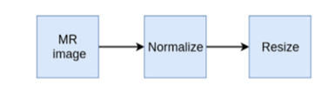
Fig 1: Data preprocessing steps[2].
The classifier settings are transfer learned deep CNN model with its softmax classifier, as a stand-alone system, deep CNN features with SVM classifier and deep CNN features with KNN classifier.
Classification accuracy is the most extensively used quality index (the ratio of the number of correctly classified samples to the total number of data samples). The data reveals that a superior performance is achieved when SVM or KNN is used to classify the deep CNN features.
Deepak and Ameer compared the performance of their method with all the existing methods on the specific 3-class classification problem of brain tumors, the comparison shows that their method surpasses all the state-of-the-art methods. The third column in the table defines the portion of the entire dataset used in training. The proposed method recorded the best result
when 80% of the data samples were used for training. Instead, they present results for the case when 56% of the dataset is used for training.
The accuracy of the system improved when SVM or KNN was used instead of the classification layer within the transfer learned model. This meant that some of the classifications, which went wrong with the softmax-based classifier (of the deep learning model), were correctly classified by the SVM- and KNN-based classifiers.

In [3] there are two types of the most aggressive and widespread tumor named Glioma: into low-grade gliomas (LGGs) and high-grade gliomas (HGGs).
The focus of current research is to form a generator that increases the contrast within subregions of the brain tissue. The generator, which is a deep neural network model, uses a real channel as input to produce the synthetic one.
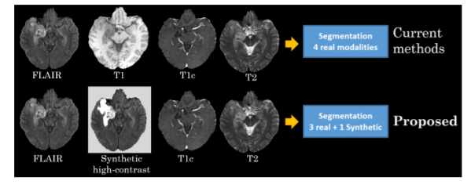
Fig 2: The pipeline outlines the steps in the current (top) and proposed synthetic (bottom) segmentation techniques.
The framework has 2 stages: generating high tissue contrast images based on FLAIR sequence in their convolutional neural network (CNN) model and training a 3D fully convolutional network (FCN) based on the synthetic images to segment regions of interest.
The method Hamghalam, Lei and Wang used is Synthetic Image Generator, deep-learning-based high-contrast synthesis using FLAIR images.They also used Synthetic Segmentation,The output volumes from synthetic image generator block are concatenated with real modalities (FLAIR, T1c, and T2) and fed into segmentation block to predict region of interests.
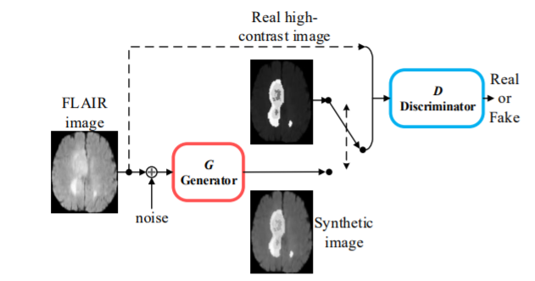
Fig 3: Deep-learning-based high-contrast synthesis using FLAIR images. After training by GAN, the model outputs the synthetic high tissue contrast images with an inference time of around 20 ms.
They implement the proposed design using the KERAS with 12GB NVIDIA TITAN X GPU. They have scaled image patches to sizes 128 × 128 pixels for translation. The model is trained through the ADADELTA optimizer. Dropout is used to avoid over-fitting over the training.
The performance of the proposed method is evaluated on the BraTS’19 dataset, which has two datasets of pre-operative MRI sequences: Training (335 cases) and Validation (125 cases). Each patient is given 155×240×240 with four channels: T1, T2, T1c, and FLAIR.
Their method performed competitive performance on a validation set (125 cases) of BraTS dataset. Results are reported in the online processing platform by BraTS’19 organizer.
BraTS’19 dataset contains 102 gross total resections (GTR) pre-operative scans out of 335 training cases in which the age of patients is available.
These subjects are applied for developing a model to predict the overall survival (OS) of the patient. They measure the volume of WT, TC, and ET after segmentation to create a feature vector to predict patient OS. They also consider the patient's age as an input feature to increase survival prediction accuracy.
They train different regression models to predict OS through supervised machine learning, including linear models, regression trees, support vector machines (SVMs) with different kernel functions, Gaussian process regression (GPR) models, and ensembles of trees.
In [4] a method to detect the tumor from MRI brain scans is presented. Usually, tumors occupy the locations of normal tissues and their intensity characteristics differ from the surrounding normal tissues. With this knowledge a method to locate the regions occupied by brain tumors has been developed. Extract the portion of the brain with the use of anisotropic diffusion process, optimal thresholding and morphological processes to separate the brain from non-brain portions. Detect abnormality by segmenting the extracted brain into four classes WM, GM, CSF and background using FCM. Check the symmetry of the CSF image to detect Abnormal tissues. Use the extended maxima transform to detect the tumor locations for tumor segmentation. It finds the peaks which are n intensity values higher than the background in regions and only on contrast.
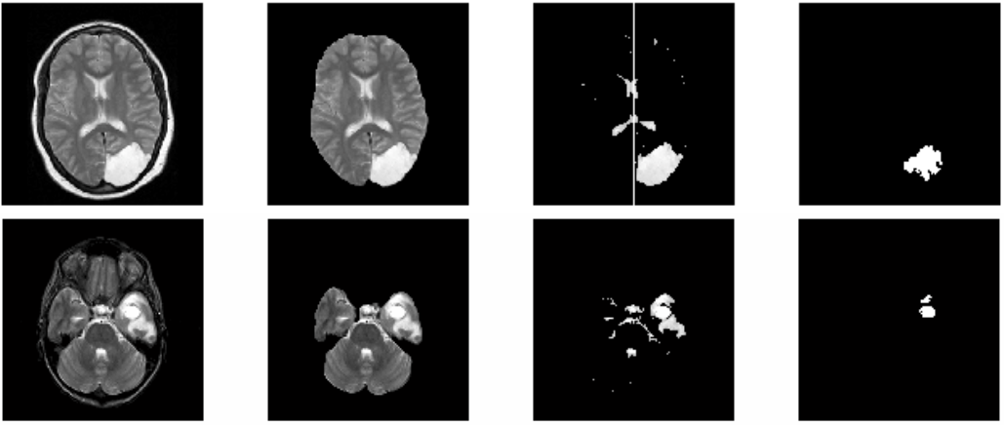
Fig 4: Two T2-w scans with tumor in row1 and row2, Original scans are given in column 1, extracted brain portions in column 2, CSF regions with central vertical line in column 3 and extracted tumor regions by extended maxima transform are in column 4 [4].
The dataset is divided into 10 volumes. The first eight datasets are from the website ‘The Whole Brain Atlas’ They are composed of 2 normal volumes and 6 abnormal volumes with brain tumor. The dimension of each slice is 256 × 256 pixels and slice thickness varying from 2–5 mm with 260 mm field of view .The remaining two datasets were taken from KGS Advanced MR & CT Scan, Madurai, Tamilnadu, India, they are composed of 2 normal volumes. The dimension of each slice is 448 × 512 pixels and 5 mm thickness. To evaluate the performance qualitative and quantitative validations were used. Three versions of the existing method predictive cognitive system for brain images (PCB), v.1, v.2 and v.3 [5–7] were used to compare results. In the qualitative validations false alarm (FA) and missed alarm (MA) were used. The FA of the proposed method in 6 out of 8 datasets is lower than all PCB versions, However the average MA in the proposed method is higher than the PCB V1 and V2. The qualitative validation of the method was done by four experts. They proposed that our method would be helpful to locate the hyper intense nature of tumors or mass effect present in either hemisphere.
In [8] a fully automatic brain tumor segmentation method based on DNNs is presented. The CNNs that are used exploit both local features as well as more global contextual features simultaneously. A 2-phase training procedure that allows to tackle problems related to the imbalance of tumor labels. Cascade architecture in which the output of a basic CNN is treated as an additional source of information for a subsequent CNN are explored. The main architectures are two-pathway and cascade. Two-pathway is made of two streams, a pathway with smaller 7 × 7 receptive fields (local path) and another with larger 13 × 13 receptive fields (global path). Conv 3x3 layer is added to the local pathway. The concatenation of the feature maps of both pathways is then fed to the output layer. The purpose of two-pathway is prediction of the label of a pixel to be influenced by the visual details of the region around that pixel and its location in the brain.
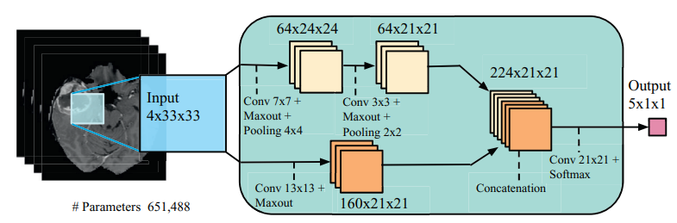
Fig 5 :Two-pathway CNN architecture (TwoPathCNN) [8].
Cascaded architectures feed the output probabilities of a first CNN as additional inputs to the layers of a second CNN. The output layer of the first CNN is concatenated with any of the layers in the second CNN. The same two-pathway structure is used for both CNNs. Three cascaded architectures are used. Input concatenation (InputCascadeCNN) provides the first CNN’s output directly as input to the second CNN. Local pathway (LocalCascadeCNN) concatenation which concatenates the first CNN’s output to the first hidden layer of the local pathway, in the second CNN. Pre-output concatenation (MFCascadeCNN), in this last architecture, the concatenation is performed at the end of the second CNN right before its output layer.
Input concatenation, we provide the first CNN’s output directly as input to the second CNN.
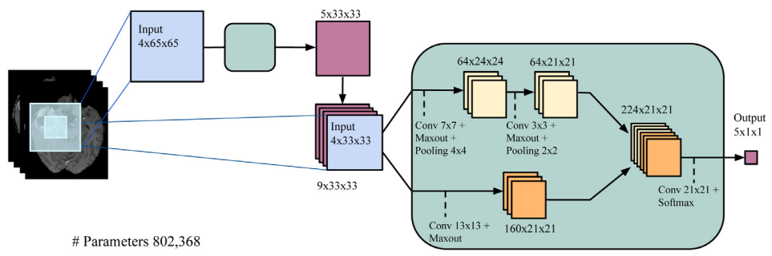
Fig 6: An example of cascaded architectures (InputCascadeCNN) [8].
The dataset that was used is BRATS2013 dataset which comprises 3 sub-datasets. The training dataset, which contains 30 patient subjects all with pixel-accurate ground truth (20 high grade and 10 low grade tumors); the test dataset which contains 10 (all high-grade tumors) and the leaderboard dataset which contains 25 patient subjects (21 high grade and 4 low grade tumors). For the two-pathway CNN architecture performance evaluation results on each pathway as well as results on averaging the outputs of each pathway when trained separately (with and without two phase training) were compared. a single path with one training phase got the lowest score but with second phase training it got a much higher score. Training the two paths together gives much better performance then training them separately. In the Cascaded architectures the Input concatenation got the best performance and outperformed all the other cascaded architectures and the two-pathway CNN architecture.
In [9] a DNN classifier is used to classify 66 brain MRIs into 4 classes ( normal, glioblastoma, sarcoma and metastatic bronchogenic carcinoma tumors). The classifier is combined with the discrete wavelet transform (DWT) which is a feature extraction tool and principal components analysis (PCA).The DNN classifying of the brain tumors in brain MRIs consists of 4 steps. Brain MRIs Dataset acquisition of 66 real human brain MRIs with 22 normal and 44 abnormal images. Collected from http://med. harvard.edu/AANLIB. All the brain MRIs were in the axial plane, T2-weighted and 256 x 256 pixels. Image segmentation using Fuzzy C-means is the task of separating the different normal brain tissues such as gray matter ,white matter ,cerebrospinal fluid and the skull from the tumor tissues in brain MR images using the Fuzzy C-means clustering technique to segment the image into 5 sections. The resulting segmented tumor part would be used in the next steps. After segmenting the Brain MR images into 5 sections, the next step is feature extraction and reduction where features of the segmented tumor are extracted using DWT. The classification step using DNN is performed on the resulting feature vector. Classification is performed by using 7-fold cross validation technique for building and training the DNN of 7 hidden layers structure.
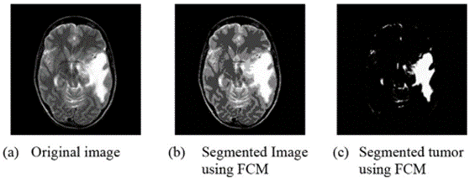
Fig 10: A sample image segmented using FCM [9].
The performance evaluation was measured with average classification rate, average recall, average precision, average F-Measure, and average area under the ROC curve (AUC) of all the four classes. DNN with the DWT got better results than KNN with k=1 and k=2, LDA and SMO [10] in all the measurements.
2.2. Background

CNN – Convolutional Neural Network
CNN is a type of deep learning model for processing data that has a grid pattern, such as images, which is inspired by the organization of animal visual cortex and designed to learn spatial hierarchies of features automatically and adaptively, from low- to high-level patterns. [11]
CNN is a mathematical construct that is typically composed of three types of layers (or building blocks): convolution, pooling, and fully connected layers. The first two, convolution and pooling layers, perform feature extraction, whereas the third, a fully connected layer, maps the extracted features into final output, such as classification. A convolution layer plays a key role in CNN, which is composed of a stack of mathematical operations, such as convolution, a specialized type of linear operation. In digital images, pixel values are stored in a two-dimensional (2D) grid, i.e., an array of numbers (Fig. 2), and a small grid of parameters called kernel, an optimizable feature extractor, is applied at each image position, which makes CNNs highly efficient for image processing, since a feature may occur anywhere in the image. As one layer feeds its output into the next layer, extracted features can hierarchically and progressively become more complex.
The process of optimizing parameters such as kernels is called training, which is performed to minimize the difference between outputs and ground truth labels through an optimization algorithm called backpropagation and gradient descent, among others.

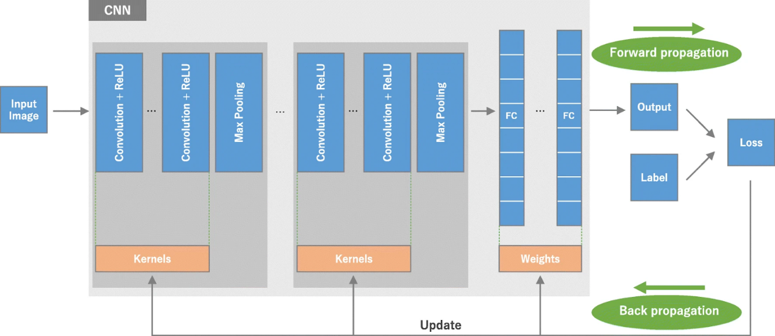

Fig 11: An overview of a CNN architecture and the training process [11].

An overview of a convolutional neural network (CNN) architecture and the training process. A CNN is composed of a stacking of several building blocks: convolution layers, pooling layers (e.g., max pooling), and fully connected (FC) layers. A model’s performance under particular kernels and weights is calculated with a loss function through forward propagation on a training dataset, and learnable parameters, i.e., kernels and weights, are updated according to the loss value through backpropagation with gradient descent optimization algorithm.

Convolution Layers
Convolutional layers are the major building blocks used in convolutional neural networks.
A convolution is the simple application of a filter to an input that results in an activation. Repeated application of the same filter to an input, results in a map of activations called a feature map, indicating the locations and strength of a detected feature in an input, such as an image. [12]

Pooling Layer
Pooling layers are used to reduce the dimensions of the feature maps. Thus, it reduces the number of parameters to learn, and the amount of computation performed in the network. The pooling layer summarizes the features present in a region of the feature map generated by a convolution layer. So, further operations are performed on summarized features instead of precisely positioned features generated by the convolution layer. This makes the model more robust to variations in the position of the features in the input image.
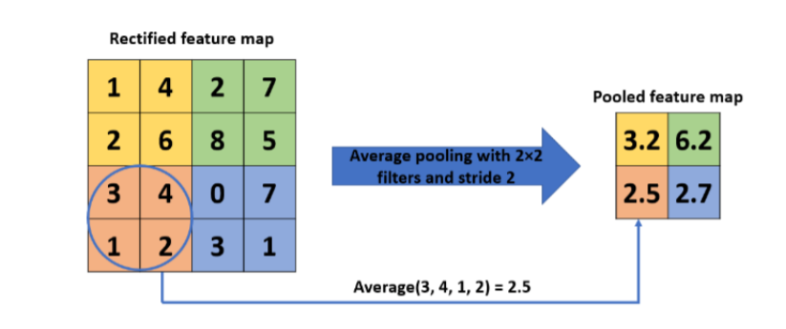
Fig 12: Example of average pooling operation

Activation Function [13]
An activation function is a function that is added into an artificial neural network in order to help the network learn complex patterns in the data. When compared with a neuron-based model that is in our brains, the activation function is at the end deciding what is to be fired to the next neuron.

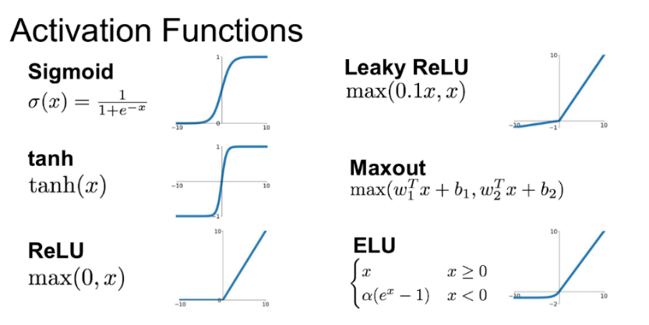
Fig 13: Different Activation Functions and their Graphs.

Fully Connected Layer
Fully Connected Layer is a layer where its neurons have full connection to all activations in the previous layer. Its purpose is to take the output of the convolution/pooling process (flattened to a vector) and use them to classify the image into a label.
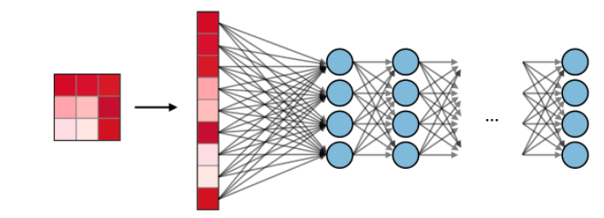
Fig 14: Fully Connected Layers [14].

Softmax
The softmax step can be seen as a generalized logistic function that takes as input a vector of scores x ∈ R^{n} and outputs a vector of output probability p ∈R^{n} through a softmax function at the end of the architecture. It is defined as follows:

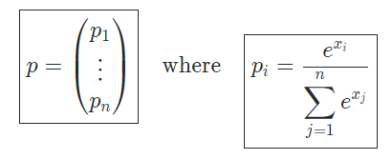

Transfer Learning [15]
Transfer Learning is to train a model for a task and use the knowledge it gained for a different task. It is an optimization, a shortcut to saving time or getting better performance. If a model is trained on a large and general dataset, we can use the feature maps it learned on other tasks without the need to start from scratch by training a large model on a large dataset. Pre-trained Model Approach: Select an initial model, a pre-trained model is chosen from available models. Reuse Model, use the knowledge (pre-trained weights) of the pre-trained model as a starting point for the second task. This can be done by using all or parts of the model. Tune Mode, the model may need to be adapted or refined on the input-output pair data available for the task of interest. Benefits of transfer learning are: Higher performance starting point, the initial performance is higher due the use of feature maps from the pre-trained model. Higher slope, the rate of performance improvement during training is steeper. Higher asymptote, the convergence of the pre- trained model is better. Lack of data, if a task has a low amount of data, using transfer learning may help the model learn more complex features.
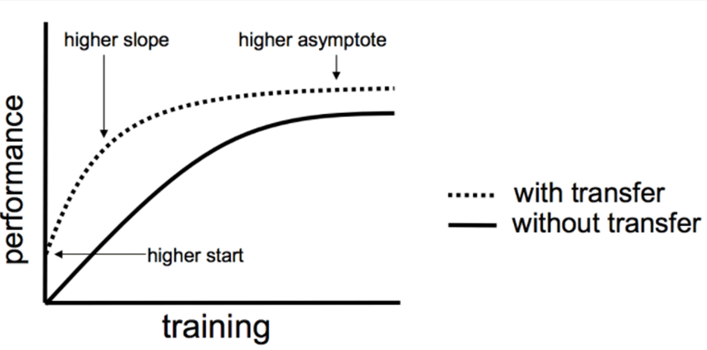
Fig 15: Three ways in which transfer might improve learning [15].

3. Expected Achievements
We expect to build a system that will be able to correctly classify whether a person has a brain tumor or not by inserting an MRI scan.
This system will be developed and implemented by using Deep networks for image processing.
We will create a CNN network and train it with MRI scans of people with brain tumors.
We look forward to exploring a few different CNN architectures to build a classification system that will be classified at the best possible.
Our CNN model is going to be based on DenseNet and Inception V4 architectures. We are going to compare the model's result according to the learning rate, epochs, and loss. We will use transfer learning to help us train the models. We want to build an optimal deep learning system, with small errors.
We expect that our system will classify correctly with a 0.8-0.95 success rate.
The system will help us identify early whether a person has a brain tumor and thus help him deal with the disease in its early stages and not in advanced stages, also it will help patients receive less invasive diagnoses and treatments.
This task is challenging due to the high variance in appearance and shape, ambiguous boundaries, and imaging artifacts, while automatic segmentation has the advantage of fast speed, consistency in accuracy and immunity to fatigue.
In addition, the whole field of deep learning and CNN networks is a very evolving field in the last 10 years and there is still not enough knowledge/research that we can use.
4. Research Process

4.1. CNN Architectures research
The CNN Architectures researched include the following:
DenseNets [16]
In this architecture each layer obtains additional inputs from all preceding layers and passes on its own feature-maps to all subsequent layers. This is done to enable maximum information flow between the layers of the network. The features are combined by concatenating them. The L th layer has L inputs, consisting of the feature-maps of all preceding convolutional blocks. Its own feature-maps are passed on to all subsequent layers. There are L(L+1)/2 connections in an L-layer network.
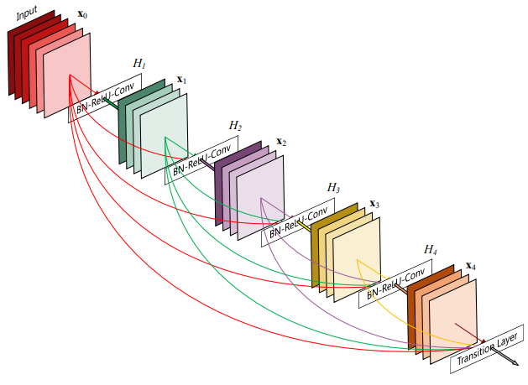
Fig 16: A 5-layer dense block with a growth rate of k = 4. Each layer takes all preceding feature-maps as input [16].
DenseNet layers are very narrow, adding only a small set of feature-maps to the “collective knowledge” of the network and keep the remaining feature maps unchanged, and the final classifier decides based on all feature-maps in the network. A dense connectivity pattern requires fewer parameters, as there is no need to relearn unnecessary feature-maps. DenseNets have improved flow of information and gradients throughout the network, which makes the net easier to train. dense connections have a regularizing effect, which reduces overfitting on tasks with smaller training set sizes.

DenseNets Architecture:
- Dense connectivity, direct connections from any layer to all subsequent layers. The L th layer receives the feature-maps of all preceding layers, x0, . . ., xL−1, as input: xL = HL ([x0, x1, . . ., xL−1]), because of its dense connectivity we refer to this network architecture as Dense Convolutional Network (DenseNet).
- Composite function, define HL (·) as a composite function of three consecutive operations: BN, ReLU and a 3 × 3 Conv.
- Pooling layers, the concatenation operation used in dense connectivity cannot be performed if the size of feature-maps is different. An essential part of convolutional networks is down-sampling layers that change the size of feature-maps. To facilitate down-sampling in our architecture we divide the network into multiple densely connected dense blocks.
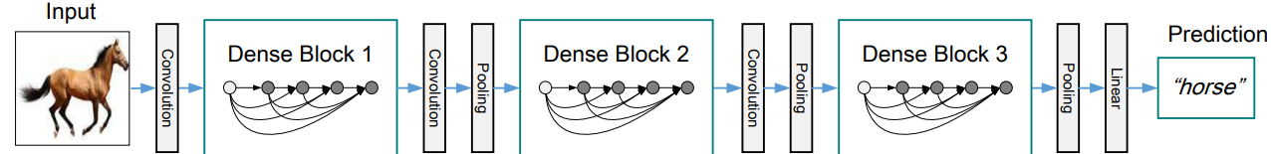
Fig 17: A deep DenseNet with three dense blocks. The layers between two adjacent blocks are referred to as transition layers and change feature-map sizes via convolution and pooling [16].
- Growth rate, if each function HL produces k feature maps, it follows that the L th layer has k0 +k ×(L−1) input feature-maps, where k0 is the number of channels in the input layer. The hyper parameter k is the growth rate of the network.
- Bottleneck layers, 1×1 convolution can be used as a bottleneck layer before each 3×3 convolution to reduce the number of input feature-maps and improve computational efficiency.
- Compression, to improve model compactness, we can reduce the number of feature-maps at transition layers by letting the following transition layer generate ⌊θm⌋ output feature maps, where 0 < θ ≤1.

Inception-v4 [17]
Inception-v4 is a convolutional neural network architecture that builds on previous iterations of the Inception family by simplifying the architecture and using more inception modules than Inception-v3.
The Inception deep convolutional architecture was introduced as GoogLeNet in (Szegedy et al. 2015a), here named Inception-v1. Later the Inception architecture was refined in various ways, first by the introduction of batch normalization (Ioffe and Szegedy 2015) (Inception-v2). Later by additional factorization ideas in the third iteration (Szegedy et al. 2015b) which will be referred to as Inception-v3.
Our older Inception models used to be trained in a partitioned manner, where each replica was partitioned into multiple sub-networks in order to be able to fit the whole model in memory.
However, the Inception architecture is highly tunable, meaning that there are a lot of possible changes to the number of filters in the various layers that do not affect the quality of the fully trained network. In order to optimize the training speed, they used to tune the layer sizes carefully in order to balance the computation between the various model sub-networks. This is enabled in part by recent memory optimizations to backpropagation, achieved by carefully considering which tensors are needed for gradient computation and structuring the computation to reduce the number of such tensors. In their newer experiments, for Inception-v4 they decided to shed this unnecessary baggage and made uniform choices for the Inception blocks for each grid size. The full configuration of the Inception-v4 network is outlined in Figures 1, which contains the overall schema and stem configuration and Figure 2, which details the construction of the interior modules.

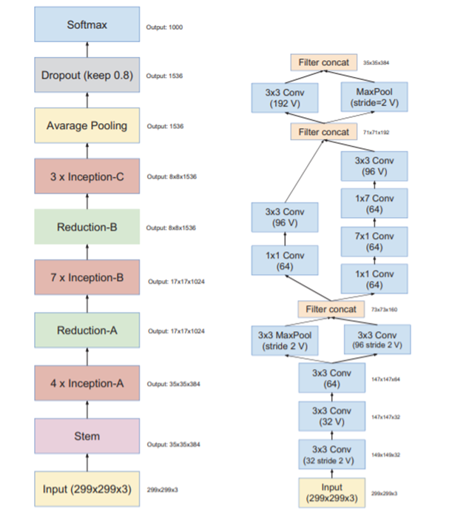
Fig 18: On the left is the overall schema for the pure Inception-v4 network. On the right is the detailed composition of the stem [17].
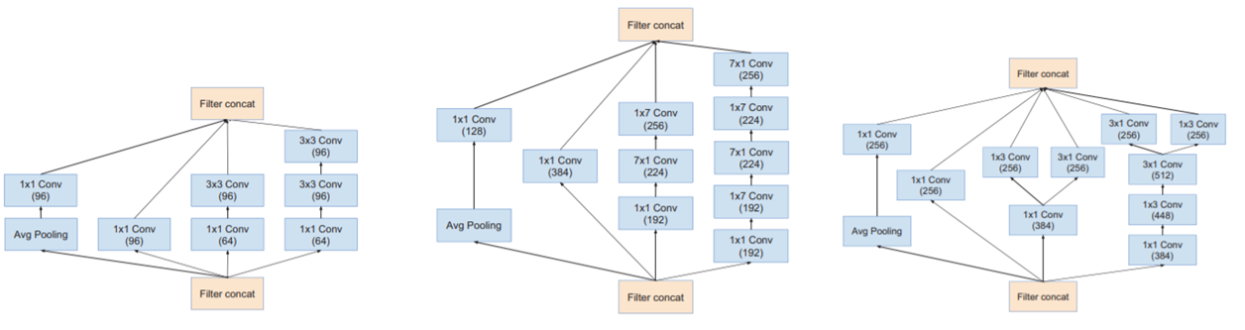
Fig 19: The schema for interior grid modules of the pure Inception-v4 network. The 35 × 35, 17 × 17 and 8 × 8 grid modules are depicted from left to right. These are the Inception-A, Inception-B, and Inception-C blocks of Figure 1 respectfully [17].
The Inception-v4 model can be trained without partitioning replicas unlike the previous versions of inceptions which required different replicas to fit in memory. This architecture uses memory optimization on back propagation to reduce the memory requirement.
In [17], Szegedy, Ioffe, Vanhoucke and Alemi compared the two pure Inception variants, Inception-v3 and v4, with similarly expensive hybrid Inception-ResNet versions. Admittedly, those models were picked in a somewhat ad hoc manner with the main constraint being that the parameters and computational complexity of the models should be somewhat similar to the cost of the non-residual models. They have tested bigger and wider Inception-ResNet variants, and they performed at the level of Inception-ResNet-v2 on the ImageNet classification challenge dataset. [17]
Lastly, they report an evaluation of an ensemble of all models described. As it was apparent that both Inception-v4 and Inception-ResNet-v2 performed similarly well.
The models Inception-v3 and Inception-v4 are deep convolutional networks not utilizing residual connections while InceptionResNet-v1 and Inception-ResNet-v2 are Inception style networks that utilize residual connections instead of filter concatenation.
Dataset
The dataset that is used is BraTS 2021 [18]. This dataset is a collection of brain tumor mpMRI scans from different institutions under standard clinical conditions, but with different equipment and imaging protocols. The dataset contains pathologically confirmed diagnosis and available MGMT promoter methylation status. The mpMRI scans included in the BraTS 2021: Fluid Attenuated Inversion Recovery (FLAIR), T1-weighted pre-contrast (T1w), T1-weighted post-contrast (T1Gd), T2-weighted (T2). The input image size is 240x240x155 [19].
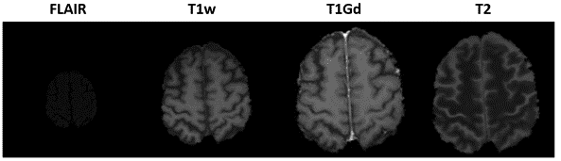
Fig 20: BraTS 2021 dataset examples [18].
MGMT Promoter Methylation Data (MGMT) is the promoter methylation status data and defined as 0 for unmethylated and 1 for methylated. It is a csv file with corresponding identifiers of the mpMRI volumes. Total Data consists of 2040 mpMRI glioma cases each with four 3D MRI modalities (T1, T1c, T2 and FLAIR) ,Training Data = 1251, Validation Data = 219, Testing Data = 570.
The Researched hyperparameters we will research, and test in the model are as follows:
- Learning rate {0.00005 – 0.0000005}
- Epochs {50, 100, 150}
- Batch size {32, 64}
- Dropout {0.2-0.5}

4.2. Product:

The system we will develop, after deep study of the parameters, will be able to predict brain cancer with a maximum error of 8-10 percent.

Sequence diagram - using the system:
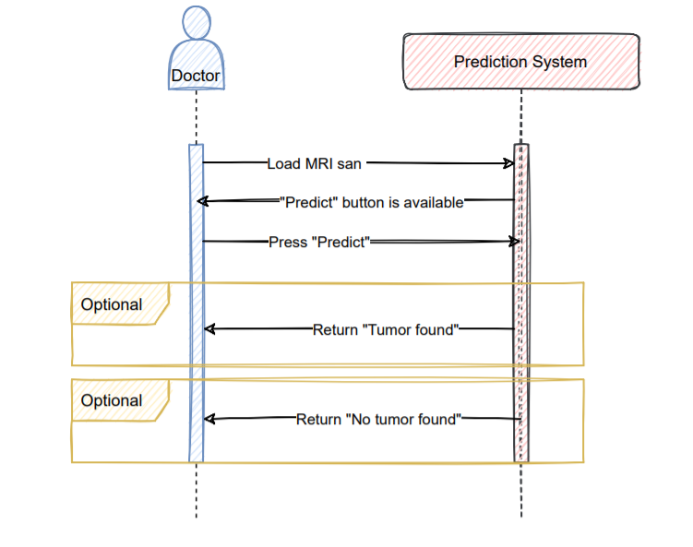

Flowchart - system preparations and use:

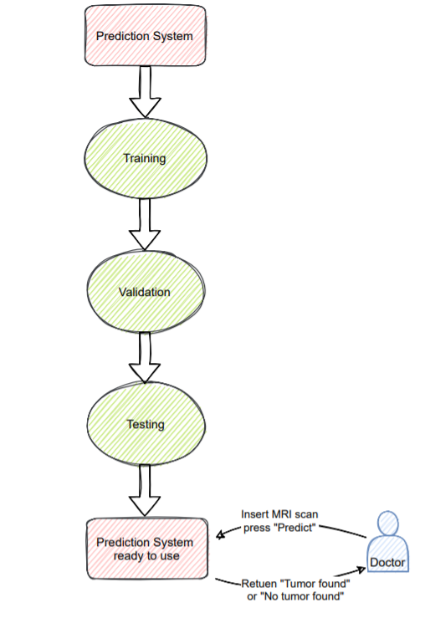

GUI

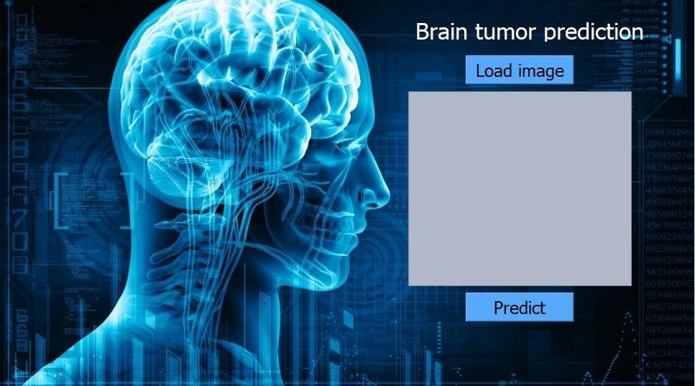

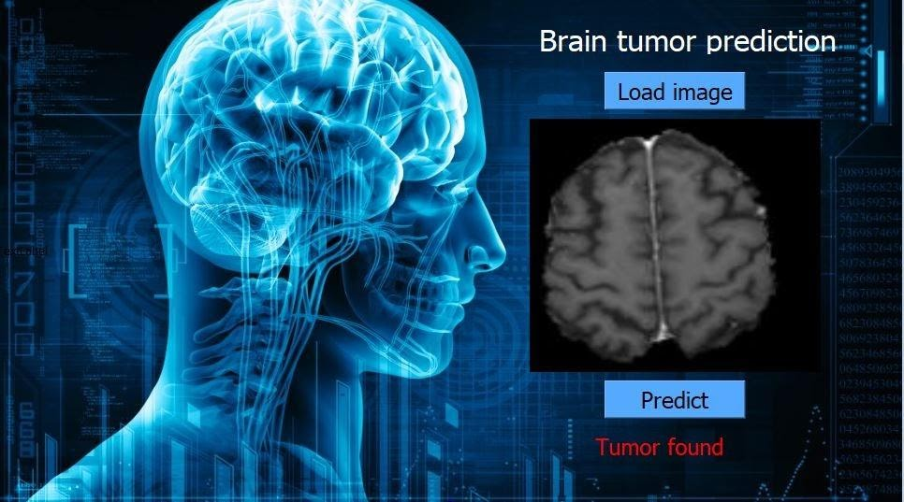

5. Evaluation / Verification Plan

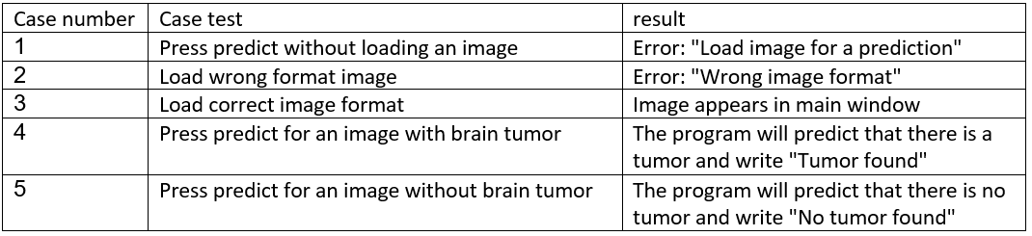

6. References
[1] RSNA-MICCAI Brain Tumor Radiogenomic Classification
[2] S. Deepak, P.M. Ameer, “Brain tumor classification using deep CNN features via transfer learning”, Computers in Biology and Medicine volume 111, August 2019, 103345.
[3] Mohammad Hamghalam, Baiying Lei and Tianfu Wang,”Brain Tumor Synthetic Segmentation in 3D Multimodal MRI Scans”, arXiv:1909.13640v2 [eess.IV] 29 May 2020.
[4] Somasundaram, K., and T. Kalaiselvi. "Automatic detection of brain tumor from MRI scans using maxima transform." UGC Sponsored National Conference on Image Processing-NCIMP. 2010.
[5] P.Y. Lau and S. Ozawa, “PCB: A Predictive System for Classifying Multimodel Brain Tumor Images in an ImageGuided Medical Diagnosis Model”, in Proc. 12th International Conference on Intelligent System for Molecular Biology, Glasgow, UK, 2004
[6] P.Y. Lau and S. Ozawa, “A Region- and Image-Based Predictive Classification System for Brain Tumor Detection”, in Proc. Symposium on Biomedical Engineering, Hokkaido, Japan, pp. 72–102, 2004.
[7] P.Y. Lau and S. Ozawa, “A Multiparameter Hierarchical Representation using Region-Based Estimation Model for Detecting Tumor in T2-Weighted MRI Brain Images”, Malaysian Journal Of Computer Science, Vol. 18, No. 1, pp. 1–19, 2005.
[8] M. Havaei, A. Davy, D. Warde-Farley, A. Biard, A. Courville, Y. Bengio, C. Pal, P.-M. Jodoin, and H. Larochelle, “Brain tumor segmentation with deep neural networks,” arXiv preprint arXiv:1505.03540, 2015.
[9.] H. Mohsen, E.A. El-Dahshan, E.M. El-Horbaty, A.M. Salem, “Classification using Deep Learning Neural Networks for Brain Tumors,” Future Computing and Informatics Journal, 2017.
[10] Mohsen, H., El-Dahshan, E.A., El-Horbaty, E.M., Salem, A.M. Brain tumor type classification based on support vector machine in magnetic resonance images, Annals Of “Dunarea De Jos” University Of Galati, Mathematics, Physics, Theoretical mechanics, Fascicle II, Year IX (XL), No. 1; 2017.
[11] Rikiya Yamashita, Mizuho Nishio, Richard Kinh Gian Do and Kaori Togashi, “Convolutional neural networks: an overview and application in radiology”, Insights into Imaging volume 9, pages 611–629 (2018).
[12] Jason Brownlee, " How Do Convolutional Layers Work in Deep Learning Neural Networks?", April 17, 2019 in Deep Learning for Computer Vision Tweet.

[13] Vandit Jain, " Everything you need to know about ‘Activation Functions’ in Deep learning models", Dec 30, 2019.
[14] Afshine Amidi, Shervine Amidi, “Convolutional Neural Networks cheatsheet”.
[15] L. Torrey and J. Shavlik. Transfer learning. IGI Global, 2009.
[16] Gao Huang and Zhuang Liu and Laurens van der Maaten and Kilian Q. Weinberger, Densely Connected Convolutional Networks, arXiv 1608.06993 (2016).
[17] Christian Szegedy, Sergey Ioffe, Vincent Vanhoucke, Alex Alemi, “Inception-v4, Inception-ResNet and the Impact of Residual Connections on Learning”, arXiv:1602.07261.
[18] U.Baid, et al., “The RSNA-ASNR-MICCAI BraTS 2021 Benchmark on Brain Tumor Segmentation and Radiogenomic Classification”, arXiv:2107.02314, 2021.
[19] Siddiquee, Md Mahfuzur Rahman, and Andriy Myronenko. "Redundancy Reduction in Semantic Segmentation of 3D Brain Tumor MRIs." arXiv preprint arXiv:2111.00742 (2021).‏

